Assignment 2 – Building a eStore Script

Go to this site:

<http://www.cems.uwe.ac.uk/assignments/10029052/wp/assignment/index.php>

Test all the functionality of this site. You are supposed to replicate this site. To make things easier some of the specs are defined below

ER Model

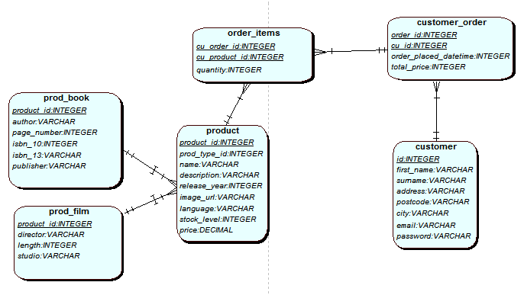

From this you can easily create the database

1. Index.PHP – All Products
2. Product.PHP (Parameter ID );
3. Checkout.PHP
4. Register.php (Register)
5. Login.PHP

All functions should be in their respective files.

e.g header.php

footer.php